Incoterms Explained: Website revamp

RAK comments on version 1

Home page

Top area – “Incoterms Explained” banner plus main navigation

Slider area – currently two slides (but the same)

CP>> Correct, I am waiting on Mark for further slides, the technical implementation is in place, I just need the images. I believe Mark is waiting on you for a strtapline etc.

Main area – slogan “Guidance and training … “ plus three panels.

You have implemented what Mark has specified, but to my mind we need to create a colour contrast between the background of the page and the background of the panels themselves – perhaps make the latter a light grey or cyan

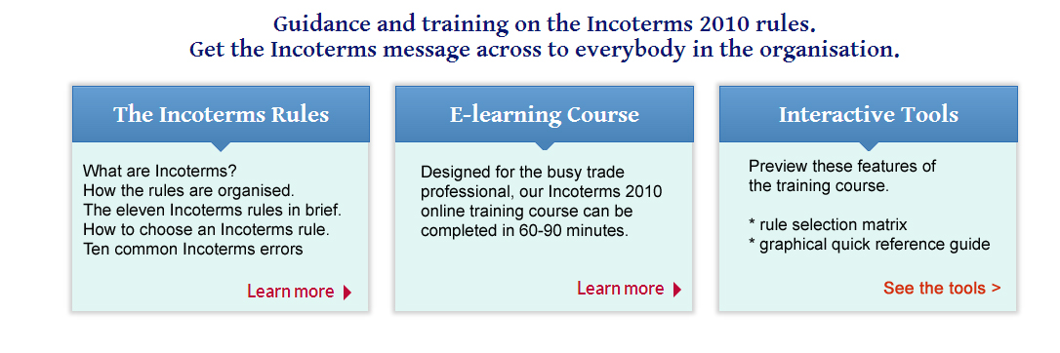

AP>> Done.
Contents of the panels

Would these look better left-justified?

The Incoterms rules.

What are Incoterms?
How the rules are organised.
The eleven Incoterms rules in brief.
How to choose an Incoterms rule.
Ten common Incoterms errors.
Learn more >

E-learning course

Designed for the busy trade
professional, our Incoterms 2010
online training course can be
completed in 60-90 minutes.
Learn more >

Interactive tools

Preview these features of
the training course.

- rule selection matrix
- graphical quick reference guide
See the tools >

CP>> If we are looking at design changes I suggest we get Mark involved, there’s reasons why he has designed and laid out the site in the manner

HAVE UPDATED TEXT, NEEDS TIDYING THOUGH, YOU’LL SEE WHAT I MEAN
AP>> Done.

2010 REVISION: The United States perspective

Why the new rules are important to US companies and their trading partners.

(Delete following sentence) What about the UCC provisions?

CP>> Am unable to find a sentence in this page that begins with - What about the UCC provisions – please clarify.

RAK >>>
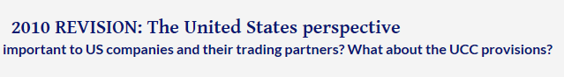
The tabbed system for enquiries

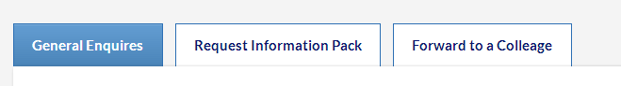
General Enquiries >. (typo) General enquiries {NB lower case)

Request Information Pack >. Request information pack {lower case}

Forward to a Colleage (NB typo) Change to “Send to a colleague” {NB lower case}

CP>> Done

RAK >>> Still a typo “colleague”



“General enquiries” form

Make Forename, Surname, Company and email address required fields with Asterisks (*)

CP>> Done

“Request information” form

Enter your details to receive our FREE information pack
about Mantissa’s “Introduction to Incoterms 2010” e-learning

Should somebody else in your organisation know about this?
Select “Send to a colleague”

Make Forename, Surname, Company and email address required fields with Asterisks (*)

CP>> Done

RAK >> what has happened to alignment of email address field (IE and Chrome?

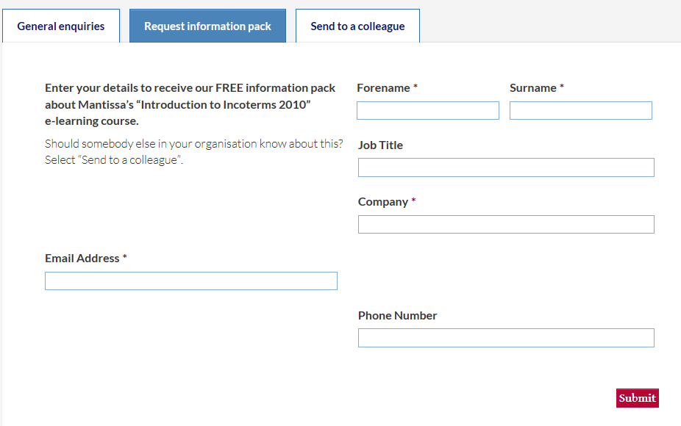

>>> RAK
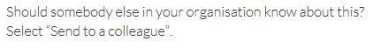
Suggest “Select “Send to a colleague”{bold} tab “
AP>> Done.

Send to a colleague

Enter your own and your colleague’s details – our FREE information pack on Mantissa’s “Introduction to Incoterms 2010” e-learning will be sent to your colleague

(Your details: all three fields are required)

Colleague’s details (NB missing apostrophe. Forename, Surname and email are required. Remove the phone number field – nobody will use it!)

CP>> Done

See end of this document for the email auto-responses

>> RAK Home page bottom navigation panel – typo “About Mantissa”



The Incoterms Rules

General issues

Right-hand pane with the text for each section (“The Incoterms 2010 rules”, “the logic of the rules” etc.

The title for the pane needs to be larger and/or bolder.

CP>> Please define how much larger? 10% 100%?

RAK >>> Something like this – do you want a JPEG, or will this do?
It is Adobe Garamond Pro 22 pixels in Photoshop. (But not necessarily this font obviously)

AP>> Done. On main pages. H1 for large blue heading and h2 for smaller heading. Is this correct?

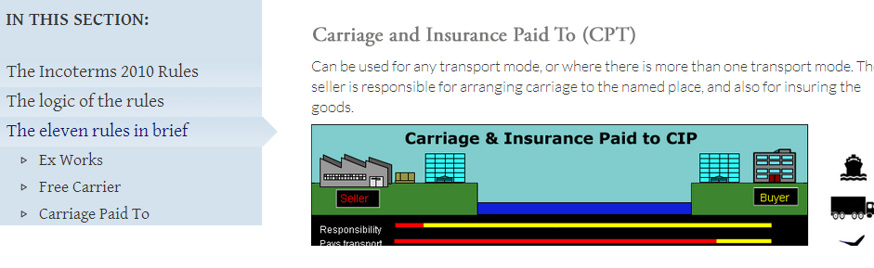

The “Read more” panel on the EXW pages etc – can you create empty pages with the title e.g. “Ex Works (EXW) – further notes”, and I will populate these?

CP>> Done

Left-hand navigation panel – I can’t see us making any use of Twitter or Facebook in the short term. I suggest you hide these icons
AP>> No icons there.
Specific pages

The logic of the rules

Is there a way of giving me a border for this table, and/or a vertical rule between the two columns?
AP>> Done

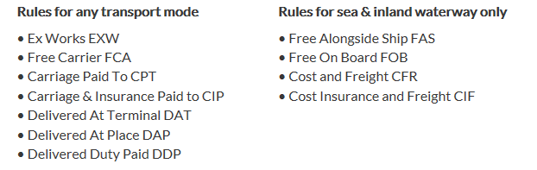

Missing space – pays for transport

Free carrier

The “Next” link at the bottom – should point to “Carriage Paid to”, not “Free Carrier”

CP>> Done

Carriage paid to

Needs a “Read More” button and a link to an empty page

Carriage and Insurance Paid To (CIP)

Needs a “Read More” button and a link to an empty page

Delivered at Terminal (DAT)

Needs a “Read More” button and a link to an empty page

Delivered at Place (DAP)

Needs a “Read More” button and a link to an empty page

Delivered Duty Paid (DDP)

Needs a “Read More” button and a link to an empty page
Free Alongside Ship (FAS)

Needs a “Read More” button and a link to an empty page

Free On Board (FOB)

Needs a “Read More” button and a link to an empty page

Cost and Freight (CFR)

Needs a “Read More” button and a link to an empty page

Cost Insurance and Freight (CIF)

Needs a “Read More” button and a link to an empty page

CP>> Done

Common mistakes in using the Incoterms rules
Can the style be altered to create more white space separating the bullet points?

CP>> Will Add 10px underneath the items
RAK>> Thanks, much better.

We now have an extra bullet point at the end ( – makes number = 10)

When DAT or DAP is used with a “post-clearance” delivery point, failure to think through the liaison required between the carrier and the customs authorities – can lead to delays and extra costs

CP>> Added

Frequently asked questions

“.. please get in touch” – make this a link to the “General enquiries” tab of the form

CP>> Done

The Incoterms 2010 rules and letters of credit

More space separating out the sections please (above the title “Why the C rules work best ..”

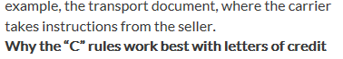
CP>> Done.

Incoterms 2010: The US view

Remove “Next: ICC updates”. ICC page has been removed

CP>> Unable to find in page, please clarify
RAK>> Can’t find it either! Not sure what I was getting at

E-learning Course

The title of the course is “Introduction to Incoterms 2010 rules”, so this must be reflected in the page title.

“Introduction to Incoterms 2010 rules”
e-learning course

CP>> Done
Top bullet points – can we have more space between the items? (Style sheet change?)

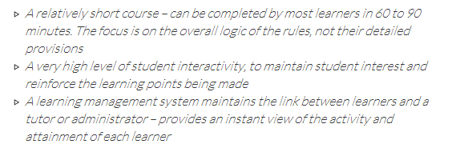

CP>> Will change with the update above
AP>> Done

“Key benefits of the e-learning course” – change to “Benefits of e-learning”

CP>> Done

==== CONTINUED 6 DECEMBER ============

Top section – final para

If you think …. please get in touch …. Make this a link to “General enquiries” tab of the form system
AP>> Done

Section currently headed “benefits of the e-learning”

Should be “Benefits of e-learning”. NB initial capital
AP>> Done

Need to shorten long sentence above the panels to:

Our course contains frequent interactions in order to focus the student's attention and check understanding.
AP>> Done

Need to change contents of the four panels

Convenience

Students can study at the time and place of their choosing – minimal disruption of working routines

Flexibility
Students can spread their learning over time, stopping and starting the course as necessary

Control
Students can study at their own pace – a huge benefit where English is not one’s first language. Nobody need get “left behind”

Success
The learning management system shows the activity and attainment of every student, giving everybody confidence that key learning objectives have been achieved.

AP>> Done

Screenshots too small to be useful as they currently stand. Unless the wording is large enough to be read comfortably, they will just be ignored.

Can you either rework this or do the screen shots another way?
AP>> If you provide larger versions of each slide I can make the slideshow larger. It's up to the designer.

Underneath the four “Buy now” boxes

For other student numbers, email us

Change to “For other student numbers, contact us” – and make this a link to the “General enquiries” tab of the form system

AP>> Done

Auto-responses to enquiry forms

Forms:

Auto-response for General Enquiries.

Thank you for your enquiry on the “Incoterms Explained” website.

One of Mantissa’s staff will respond to you within one or two working days.

Regards,

The Mantissa Team

CP>> Subject Required

>> RAK. Subject: Incoterms Explained: Your enquiry

Auto-response for “Request Information Pack”

Thank you for your interest in Mantissa’s “Introduction to Incoterms 2010 rules” e-learning course.

The attached PDF document contains an overview of the course, pricing etc.

Please do not hesitate to come back to us if you have any further questions, or wish to discuss using the course in your organisation.

Regards,

Roger Kreitman
Principal Consultant
Mantissa e-learning

CP>> PDF Required / Subject Required

>> RAK Subject: Incoterms Explained: Information pack

Auto-response for “Send to a colleague”

Your colleague <name> has asked us to send you an information pack on Mantissa’s “Introduction to Incoterms 2010 rules” e-learning course.

The attached PDF document contains an overview of the course, pricing etc.

We trust that this is of interest. Please do not hesitate to come back to us if you have any further questions, or wish to discuss using the course in your organisation.

Regards,

Roger Kreitman
Principal Consultant
Mantissa e-learning

CP>> PDF Required / Subject Required

RAK>> Subject: E-learning on the Incoterms 2010 rules

